Ghandhara Estate

CDA Offers OPEN AUCTION OF COMMERCIAL PLOTS in Various Sectors of Islamabad. Auction will be held on1st October 2024 to 3rd October 2024 at Ghandhara Citizen Club, F-9 Park, Islamabad.

|  |  |  |  |  |  |
| --- | --- | --- | --- | --- | --- |
| **Plot Location** | **Category** | **Plot Number** | **Size** | **FAR** | **Number of Stories Allowed** |
| I-8 Markaz | Commercial | 1-B | (160X80)  1422.22 Sq.Yds | 1:6 | LG+G+07 or G+8 |

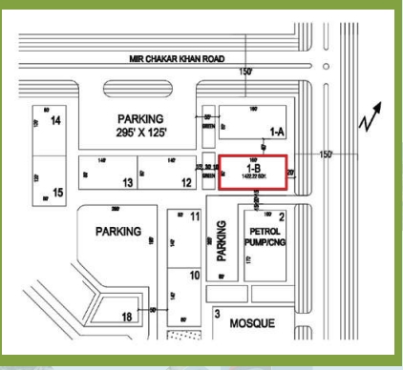

* **10% Rebate:** For those who pay the full amount within one month of the auction.
* **Additional 5% Rebate:** Available for payments made in US dollars through a banking transfer to the CDA account.

This auction presents a **golden investment opportunity** for those looking to expand their portfolio with premium commercial properties in Islamabad. Don’t miss your chance to invest in one of Pakistan’s most sought-after locations.

For further assistance and details, Ghandhara Estate is here to help you every step of the way.

<https://ghandharaestate.com/>

Ghandhara Estate

CDA Offers OPEN AUCTION OF COMMERCIAL PLOTS in Various Sectors of Islamabad. Auction will be held on1st October 2024 to 3rd October 2024 at Ghandhara Citizen Club, F-9 Park, Islamabad.

|  |  |  |  |  |  |
| --- | --- | --- | --- | --- | --- |
| **Plot Location** | **Category** | **Plot Number** | **Size** | **FAR** | **Number of Stories Allowed** |
| I-8 Markaz | Commercial | 53-B | (100x60)  666.67 Sq.Yds. | 1:5 | LG+G+05 or G+6 |

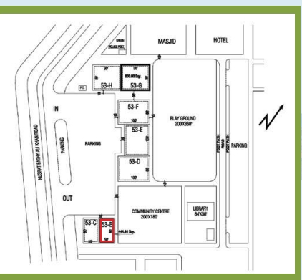

* **10% Rebate:** For those who pay the full amount within one month of the auction.
* **Additional 5% Rebate:** Available for payments made in US dollars through a banking transfer to the CDA account.

This auction presents a **golden investment opportunity** for those looking to expand their portfolio with premium commercial properties in Islamabad. Don’t miss your chance to invest in one of Pakistan’s most sought-after locations.

For further assistance and details, Ghandhara Estate is here to help you every step of the way.

<https://ghandharaestate.com/>

Ghandhara Estate

CDA Offers OPEN AUCTION OF COMMERCIAL PLOTS in Various Sectors of Islamabad. Auction will be held on1st October 2024 to 3rd October 2024 at Ghandhara Citizen Club, F-9 Park, Islamabad.

**PLOT NO. 13-X, F-7 Markaz**

|  |  |  |  |  |  |
| --- | --- | --- | --- | --- | --- |
| **Plot Location** | **Category** | **Plot Number** | **Size** | **FAR** | **Number of Stories Allowed** |
| F-7 Markaz | Commercial | **13-X** | (60X105)  700 Sq.Yds. | 1:5 | LG+G+05 or G+6 |

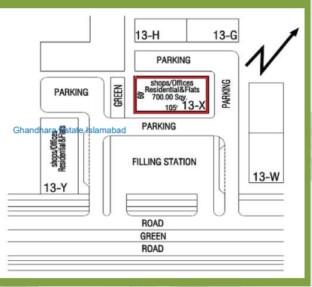

* **10% Rebate:** For those who pay the full amount within one month of the auction.
* **Additional 5% Rebate:** Available for payments made in US dollars through a banking transfer to the CDA account.

This auction presents a **golden investment opportunity** for those looking to expand their portfolio with premium commercial properties in Islamabad. Don’t miss your chance to invest in one of Pakistan’s most sought-after locations.

For further assistance and details, Ghandhara Estate is here to help you every step of the way.

<https://ghandharaestate.com/>

Ghandhara Estate

CDA Offers OPEN AUCTION OF COMMERCIAL PLOTS in Various Sectors of Islamabad. Auction will be held on1st October 2024 to 3rd October 2024 at Ghandhara Citizen Club, F-9 Park, Islamabad.

**PLOT NO. 13-G, F-8 Markaz**

|  |  |  |  |  |  |
| --- | --- | --- | --- | --- | --- |
| **Plot Location** | **Category** | **Plot Number** | **Size** | **FAR** | **Number of Stories Allowed** |
| F-8 Markaz | Commercial | **13-G** | (50x120)  666.66 Sq.Yds | 1:5 | LG+G+05 or G+6 |

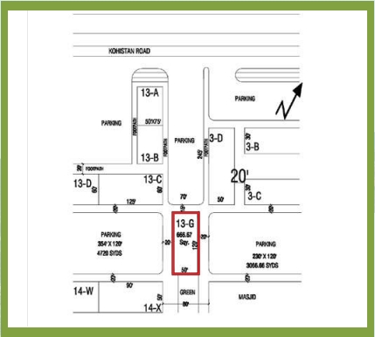

* **10% Rebate:** For those who pay the full amount within one month of the auction.
* **Additional 5% Rebate:** Available for payments made in US dollars through a banking transfer to the CDA account.

This auction presents a **golden investment opportunity** for those looking to expand their portfolio with premium commercial properties in Islamabad. Don’t miss your chance to invest in one of Pakistan’s most sought-after locations.

For further assistance and details, Ghandhara Estate is here to help you every step of the way.

<https://ghandharaestate.com/>

Ghandhara Estate

CDA Offers OPEN AUCTION OF COMMERCIAL PLOTS in Various Sectors of Islamabad. Auction will be held on1st October 2024 to 3rd October 2024 at Ghandhara Citizen Club, F-9 Park, Islamabad.

**PLOT NO. 16-D, F-8 Markaz**

|  |  |  |  |  |  |
| --- | --- | --- | --- | --- | --- |
| **Plot Location** | **Category** | **Plot Number** | **Size** | **FAR** | **Number of Stories Allowed** |
| F-8 Markaz | Commercial | **16-D** | (60x125)  833.33 Sq.Yds. | 1:5 | LG+G+05 or G+6 |

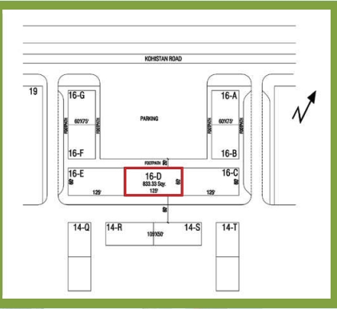

* **10% Rebate:** For those who pay the full amount within one month of the auction.
* **Additional 5% Rebate:** Available for payments made in US dollars through a banking transfer to the CDA account.

This auction presents a **golden investment opportunity** for those looking to expand their portfolio with premium commercial properties in Islamabad. Don’t miss your chance to invest in one of Pakistan’s most sought-after locations.

For further assistance and details, Ghandhara Estate is here to help you every step of the way.

<https://ghandharaestate.com/>

Ghandhara Estate

CDA Offers OPEN AUCTION OF COMMERCIAL PLOTS in Various Sectors of Islamabad. Auction will be held on1st October 2024 to 3rd October 2024 at Ghandhara Citizen Club, F-9 Park, Islamabad.

**PLOT NO. 4-D, G-8 Markaz**

|  |  |  |  |  |  |
| --- | --- | --- | --- | --- | --- |
| **Plot Location** | **Category** | **Plot Number** | **Size** | **FAR** | **Number of Stories Allowed** |
| G-8 Markaz | Commercial | **4-D** | (50x60)  333.33 Sq.Yds. | 1:5 | LG+G+05 or G+6 |

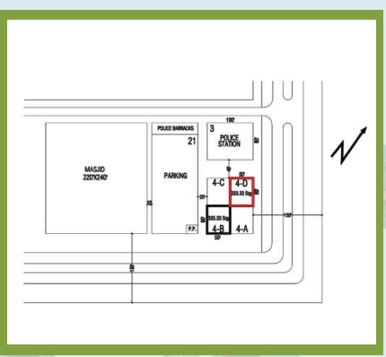

* **10% Rebate:** For those who pay the full amount within one month of the auction.
* **Additional 5% Rebate:** Available for payments made in US dollars through a banking transfer to the CDA account.

This auction presents a **golden investment opportunity** for those looking to expand their portfolio with premium commercial properties in Islamabad. Don’t miss your chance to invest in one of Pakistan’s most sought-after locations.

For further assistance and details, Ghandhara Estate is here to help you every step of the way.

<https://ghandharaestate.com/>

Ghandhara Estate

CDA Offers OPEN AUCTION OF COMMERCIAL PLOTS in Various Sectors of Islamabad. Auction will be held on1st October 2024 to 3rd October 2024 at Ghandhara Citizen Club, F-9 Park, Islamabad.

**PLOT NO. 10, BLUE AREA**

|  |  |  |  |  |  |
| --- | --- | --- | --- | --- | --- |
| **Plot Location** | **Category** | **Plot Number** | **Size** | **FAR** | **Number of Stories Allowed** |
| Blue Area G-8 | Commercial | **10** | (120X200)  2666.66 Sq.Yds. | 1:8 | Ground Coverage 70% |

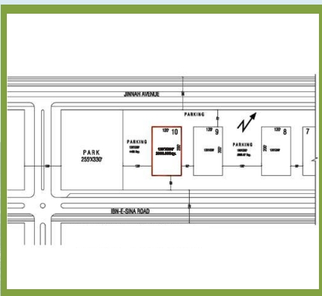

* **10% Rebate:** For those who pay the full amount within one month of the auction.
* **Additional 5% Rebate:** Available for payments made in US dollars through a banking transfer to the CDA account.

This auction presents a **golden investment opportunity** for those looking to expand their portfolio with premium commercial properties in Islamabad. Don’t miss your chance to invest in one of Pakistan’s most sought-after locations.

For further assistance and details, Ghandhara Estate is here to help you every step of the way.

<https://ghandharaestate.com/>

Ghandhara Estate

CDA Offers OPEN AUCTION OF COMMERCIAL PLOTS in Various Sectors of Islamabad. Auction will be held on1st October 2024 to 3rd October 2024 at Ghandhara Citizen Club, F-9 Park, Islamabad.

**PLOT NO. 63-B , Blue Area F-7**

|  |  |  |  |  |  |
| --- | --- | --- | --- | --- | --- |
| **Plot Location** | **Category** | **Plot Number** | **Size** | **FAR** | **Number of Stories Allowed** |
| Blue Area F-7 | Commercial | 63-B | (300X288)  9600 Sq.Yds. | 1:12 | Ground Coverage 70% |

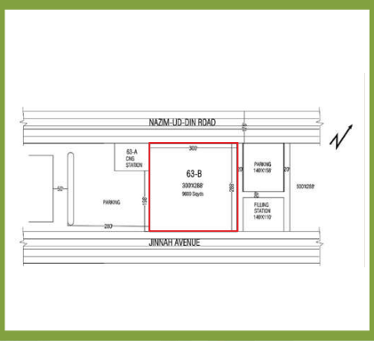

* **10% Rebate:** For those who pay the full amount within one month of the auction.
* **Additional 5% Rebate:** Available for payments made in US dollars through a banking transfer to the CDA account.

This auction presents a **golden investment opportunity** for those looking to expand their portfolio with premium commercial properties in Islamabad. Don’t miss your chance to invest in one of Pakistan’s most sought-after locations.

For further assistance and details, Ghandhara Estate is here to help you every step of the way.

<https://ghandharaestate.com/>

Ghandhara Estate

CDA Offers OPEN AUCTION OF COMMERCIAL PLOTS in Various Sectors of Islamabad. Auction will be held on1st October 2024 to 3rd October 2024 at Ghandhara Citizen Club, F-9 Park, Islamabad.

**PLOT NO. C-1 , Blue Area G-9**

|  |  |  |  |  |  |
| --- | --- | --- | --- | --- | --- |
| **Plot Location** | **Category** | **Plot Number** | **Size** | **FAR** | **Number of Stories Allowed** |
| Blue Area G-9 | Commercial | C-1 | (120X100)  1333.33 Sq.Yds | 1:8 | Ground Coverage 70% |

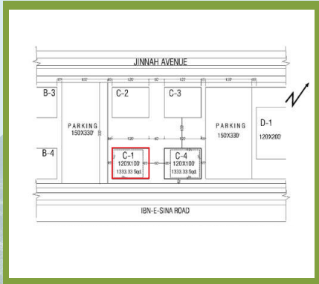

* **10% Rebate:** For those who pay the full amount within one month of the auction.
* **Additional 5% Rebate:** Available for payments made in US dollars through a banking transfer to the CDA account.

This auction presents a **golden investment opportunity** for those looking to expand their portfolio with premium commercial properties in Islamabad. Don’t miss your chance to invest in one of Pakistan’s most sought-after locations.

For further assistance and details, Ghandhara Estate is here to help you every step of the way.

<https://ghandharaestate.com/>

Ghandhara Estate

CDA Offers OPEN AUCTION OF COMMERCIAL PLOTS in Various Sectors of Islamabad. Auction will be held on1st October 2024 to 3rd October 2024 at Ghandhara Citizen Club, F-9 Park, Islamabad.

**PLOT NO. C-4 , Blue Area G-9**

|  |  |  |  |  |  |
| --- | --- | --- | --- | --- | --- |
| **Plot Location** | **Category** | **Plot Number** | **Size** | **FAR** | **Number of Stories Allowed** |
| Blue Area G-9 | Commercial | C-4 | (120X100)  1333.33 Sq.Yds | 1:8 | Ground Coverage 70% |

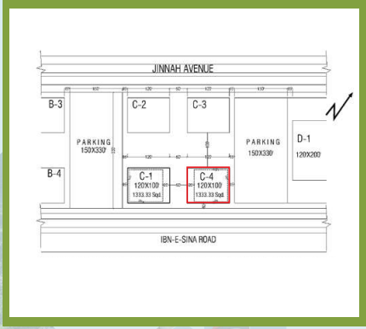

* **10% Rebate:** For those who pay the full amount within one month of the auction.
* **Additional 5% Rebate:** Available for payments made in US dollars through a banking transfer to the CDA account.

This auction presents a **golden investment opportunity** for those looking to expand their portfolio with premium commercial properties in Islamabad. Don’t miss your chance to invest in one of Pakistan’s most sought-after locations.

For further assistance and details, Ghandhara Estate is here to help you every step of the way.

<https://ghandharaestate.com/>

Ghandhara Estate

CDA Offers OPEN AUCTION OF COMMERCIAL PLOTS in Various Sectors of Islamabad. Auction will be held on1st October 2024 to 3rd October 2024 at Ghandhara Citizen Club, F-9 Park, Islamabad.

**PLOT NO. 11-C Diplomatic Enclave**

|  |  |  |  |  |  |
| --- | --- | --- | --- | --- | --- |
| **Plot Location** | **Category** | **Plot Number** | **Size** | **FAR** | **Number of Stories Allowed** |
| Diplomatic Enclave | Luxury Apartments | 11-C | (140X250)  3888.88 Sq.Yds. | 1:5 | Ground Coverage 50% |

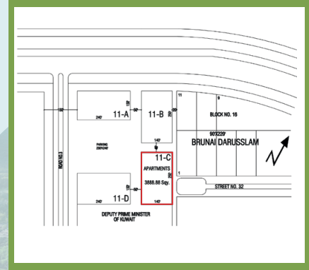

* **10% Rebate:** For those who pay the full amount within one month of the auction.
* **Additional 5% Rebate:** Available for payments made in US dollars through a banking transfer to the CDA account.

This auction presents a **golden investment opportunity** for those looking to expand their portfolio with premium commercial properties in Islamabad. Don’t miss your chance to invest in one of Pakistan’s most sought-after locations.

For further assistance and details, Ghandhara Estate is here to help you every step of the way.

<https://ghandharaestate.com/>

Ghandhara Estate

CDA Offers OPEN AUCTION OF COMMERCIAL PLOTS in Various Sectors of Islamabad. Auction will be held on1st October 2024 to 3rd October 2024 at Ghandhara Citizen Club, F-9 Park, Islamabad.

**PLOT NO. 25-B Sector G-11/1**

|  |  |  |  |  |  |
| --- | --- | --- | --- | --- | --- |
| **Plot Location** | **Category** | **Plot Number** | **Size** | **FAR** | **Number of Stories Allowed** |
| **G-11/1** | Apartments | 25-B | (150X270)  4500.00 Sq.Yds. | 1:5 | Ground Coverage 50% |

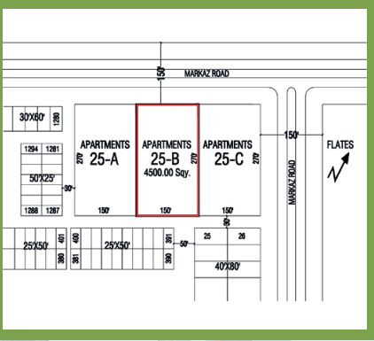

* **10% Rebate:** For those who pay the full amount within one month of the auction.
* **Additional 5% Rebate:** Available for payments made in US dollars through a banking transfer to the CDA account.

This auction presents a **golden investment opportunity** for those looking to expand their portfolio with premium commercial properties in Islamabad. Don’t miss your chance to invest in one of Pakistan’s most sought-after locations.

For further assistance and details, Ghandhara Estate is here to help you every step of the way.

<https://ghandharaestate.com/>

Ghandhara Estate

CDA Offers OPEN AUCTION OF COMMERCIAL PLOTS in Various Sectors of Islamabad. Auction will be held on1st October 2024 to 3rd October 2024 at Ghandhara Citizen Club, F-9 Park, Islamabad.

**PLOT NO. 1, Garden Avenue, off Muree Road**

|  |  |  |  |  |  |
| --- | --- | --- | --- | --- | --- |
| **Plot Location** | **Category** | **Plot Number** | **Size** | **FAR** | **Number of Stories Allowed** |
| **Garden Avenue** | Motel Site | 1 | Irregular  9534.8 Sq.Yds | 1:6 | Ground Coverage 70% |

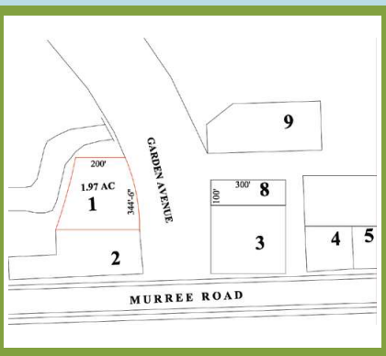

* **10% Rebate:** For those who pay the full amount within one month of the auction.
* **Additional 5% Rebate:** Available for payments made in US dollars through a banking transfer to the CDA account.

This auction presents a **golden investment opportunity** for those looking to expand their portfolio with premium commercial properties in Islamabad. Don’t miss your chance to invest in one of Pakistan’s most sought-after locations.

For further assistance and details, Ghandhara Estate is here to help you every step of the way.

<https://ghandharaestate.com/>

Ghandhara Estate

CDA Offers OPEN AUCTION OF COMMERCIAL PLOTS in Various Sectors of Islamabad. Auction will be held on1st October 2024 to 3rd October 2024 at Ghandhara Citizen Club, F-9 Park, Islamabad.

**PLOT NO. 8, Garden Avenue, off Muree Road**

|  |  |  |  |  |  |
| --- | --- | --- | --- | --- | --- |
| **Plot Location** | **Category** | **Plot Number** | **Size** | **FAR** | **Number of Stories Allowed** |
| **Garden Avenue** | Motel Site | 8 | (100X300)  3333.33 Sq.Yds | 1:6 | Ground Coverage 70% |

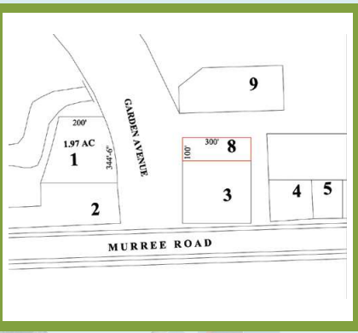

* **10% Rebate:** For those who pay the full amount within one month of the auction.
* **Additional 5% Rebate:** Available for payments made in US dollars through a banking transfer to the CDA account.

This auction presents a **golden investment opportunity** for those looking to expand their portfolio with premium commercial properties in Islamabad. Don’t miss your chance to invest in one of Pakistan’s most sought-after locations.

For further assistance and details, Ghandhara Estate is here to help you every step of the way.

<https://ghandharaestate.com/>

Ghandhara Estate

CDA Offers OPEN AUCTION OF COMMERCIAL PLOTS in Various Sectors of Islamabad. Auction will be held on1st October 2024 to 3rd October 2024 at Ghandhara Citizen Club, F-9 Park, Islamabad.

**PLOT NO. 29, Garden Avenue, off Muree Road**

|  |  |  |  |  |  |
| --- | --- | --- | --- | --- | --- |
| **Plot Location** | **Category** | **Plot Number** | **Size** | **FAR** | **Number of Stories Allowed** |
| **Garden Avenue** | Motel Site | 29 | (198X250)  5500.00 Sq.Yds | 1:6 | Ground Coverage 70% |

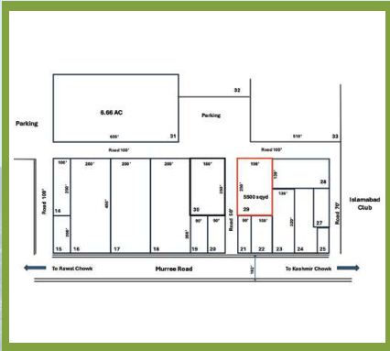

* **10% Rebate:** For those who pay the full amount within one month of the auction.
* **Additional 5% Rebate:** Available for payments made in US dollars through a banking transfer to the CDA account.

This auction presents a **golden investment opportunity** for those looking to expand their portfolio with premium commercial properties in Islamabad. Don’t miss your chance to invest in one of Pakistan’s most sought-after locations.

For further assistance and details, Ghandhara Estate is here to help you every step of the way.

<https://ghandharaestate.com/>

Ghandhara Estate

CDA Offers OPEN AUCTION OF COMMERCIAL PLOTS in Various Sectors of Islamabad. Auction will be held on1st October 2024 to 3rd October 2024 at Ghandhara Citizen Club, F-9 Park, Islamabad.

**PLOT NO. 30, Garden Avenue, off Muree Road**

|  |  |  |  |  |  |
| --- | --- | --- | --- | --- | --- |
| **Plot Location** | **Category** | **Plot Number** | **Size** | **FAR** | **Number of Stories Allowed** |
| **Garden Avenue** | Motel Site | 30 | (180X250)  5000.00 Sq.Yds | 1:6 | Ground Coverage 70% |

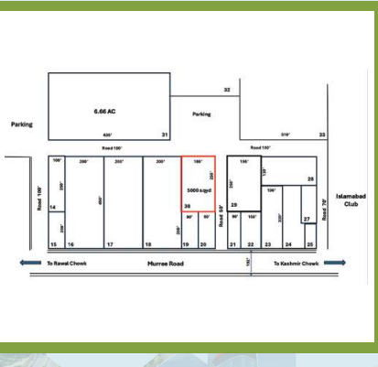

* **10% Rebate:** For those who pay the full amount within one month of the auction.
* **Additional 5% Rebate:** Available for payments made in US dollars through a banking transfer to the CDA account.

This auction presents a **golden investment opportunity** for those looking to expand their portfolio with premium commercial properties in Islamabad. Don’t miss your chance to invest in one of Pakistan’s most sought-after locations.

For further assistance and details, Ghandhara Estate is here to help you every step of the way. <https://ghandharaestate.com/>

Ghandhara Estate

CDA Offers OPEN AUCTION OF COMMERCIAL PLOTS in Various Sectors of Islamabad. Auction will be held on1st October 2024 to 3rd October 2024 at Ghandhara Citizen Club, F-9 Park, Islamabad.

**PLOT NO. 94-C, Industrial area I-10/3**

|  |  |  |  |  |  |
| --- | --- | --- | --- | --- | --- |
| **Plot Location** | **Category** | **Plot Number** | **Size** | **FAR** | **Number of Stories Allowed** |
| I-10/3 | **Industrial Plot** | 94-C | (Irregular)  2890 Sq.Yds | a) 1:1.2  b) 1:1.5  c) 1:1.6 |  |

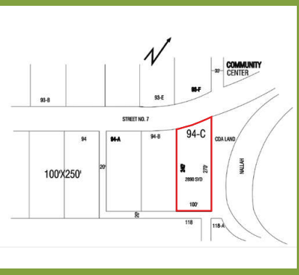

* **10% Rebate:** For those who pay the full amount within one month of the auction.
* **Additional 5% Rebate:** Available for payments made in US dollars through a banking transfer to the CDA account.

This auction presents a **golden investment opportunity** for those looking to expand their portfolio with premium commercial properties in Islamabad. Don’t miss your chance to invest in one of Pakistan’s most sought-after locations.

For further assistance and details, Ghandhara Estate is here to help you every step of the way.

<https://ghandharaestate.com/>

Ghandhara Estate

CDA Offers OPEN AUCTION OF COMMERCIAL PLOTS in Various Sectors of Islamabad. Auction will be held on1st October 2024 to 3rd October 2024 at Ghandhara Citizen Club, F-9 Park, Islamabad.

**PLOT NO. 7, Industrial Area I-10/3**

|  |  |  |  |  |  |
| --- | --- | --- | --- | --- | --- |
| **Plot Location** | **Category** | **Plot Number** | **Size** | **FAR** | **Number of Stories Allowed** |
| I-10/3 | **Industrial Plot** | 7 | (100X150)  1666.66 Sq.Yds. | a) 1:1.2  b) 1:1.5  c) 1:1.6 |  |

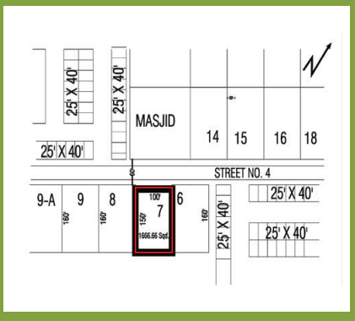

* **10% Rebate:** For those who pay the full amount within one month of the auction.
* **Additional 5% Rebate:** Available for payments made in US dollars through a banking transfer to the CDA account.

This auction presents a **golden investment opportunity** for those looking to expand their portfolio with premium commercial properties in Islamabad. Don’t miss your chance to invest in one of Pakistan’s most sought-after locations.

For further assistance and details, Ghandhara Estate is here to help you every step of the way.

<https://ghandharaestate.com/>

Ghandhara Estate

CDA Offers OPEN AUCTION OF COMMERCIAL PLOTS in Various Sectors of Islamabad. Auction will be held on1st October 2024 to 3rd October 2024 at Ghandhara Citizen Club, F-9 Park, Islamabad.

**PLOT NO. 137, INDUSTRIAL TRIANGLE KAHUTA**

|  |  |  |  |  |  |
| --- | --- | --- | --- | --- | --- |
| **Plot Location** | **Category** | **Plot Number** | **Size** | **FAR** | **Number of Stories Allowed** |
| INDUSTRIAL TRIANGLE KAHUTA | Industrial Plot | 137 | Irregular  3388.88 Sq.Yds | a) 1:1.2  b) 1:1.5  c) 1:1.6 |  |

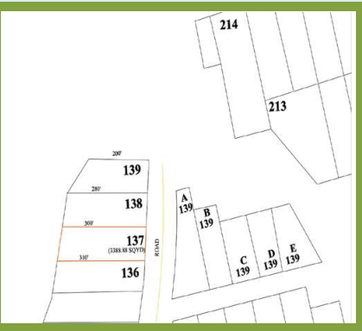

* **10% Rebate:** For those who pay the full amount within one month of the auction.
* **Additional 5% Rebate:** Available for payments made in US dollars through a banking transfer to the CDA account.

This auction presents a **golden investment opportunity** for those looking to expand their portfolio with premium commercial properties in Islamabad. Don’t miss your chance to invest in one of Pakistan’s most sought-after locations.

For further assistance and details, Ghandhara Estate is here to help you every step of the way.

<https://ghandharaestate.com/>

Ghandhara Estate

CDA Offers OPEN AUCTION OF COMMERCIAL PLOTS in Various Sectors of Islamabad. Auction will be held on1st October 2024 to 3rd October 2024 at Ghandhara Citizen Club, F-9 Park, Islamabad.

**PLOT NO. 138, INDUSTRIAL TRIANGLE KAHUTA**

|  |  |  |  |  |  |
| --- | --- | --- | --- | --- | --- |
| **Plot Location** | **Category** | **Plot Number** | **Size** | **FAR** | **Number of Stories Allowed** |
| INDUSTRIAL TRIANGLE KAHUTA | Industrial Plot | 138 | Irregular  3222.22 Sq.Yds | a) 1:1.2  b) 1:1.5  c) 1:1.6 |  |

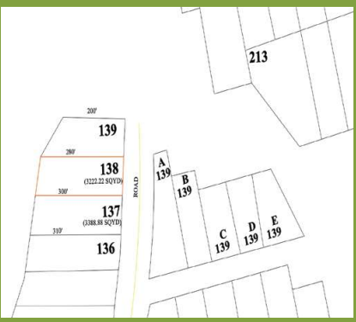

* **10% Rebate:** For those who pay the full amount within one month of the auction.
* **Additional 5% Rebate:** Available for payments made in US dollars through a banking transfer to the CDA account.

This auction presents a **golden investment opportunity** for those looking to expand their portfolio with premium commercial properties in Islamabad. Don’t miss your chance to invest in one of Pakistan’s most sought-after locations.

For further assistance and details, Ghandhara Estate is here to help you every step of the way.

<https://ghandharaestate.com/>

Ghandhara Estate

CDA Offers OPEN AUCTION OF COMMERCIAL PLOTS in Various Sectors of Islamabad. Auction will be held on1st October 2024 to 3rd October 2024 at Ghandhara Citizen Club, F-9 Park, Islamabad.

**PLOT NO. 139, INDUSTRIAL TRIANGLE KAHUTA**

|  |  |  |  |  |  |
| --- | --- | --- | --- | --- | --- |
| **Plot Location** | **Category** | **Plot Number** | **Size** | **FAR** | **Number of Stories Allowed** |
| INDUSTRIAL TRIANGLE KAHUTA | Industrial Plot | 139 | Irregular  2666.66 Sq.Yds. | a) 1:1.2  b) 1:1.5  c) 1:1.6 |  |

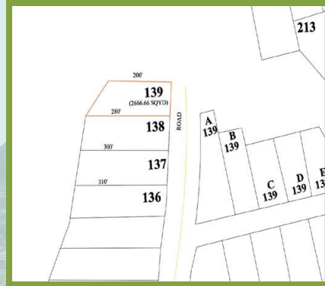

* **10% Rebate:** For those who pay the full amount within one month of the auction.
* **Additional 5% Rebate:** Available for payments made in US dollars through a banking transfer to the CDA account.

This auction presents a **golden investment opportunity** for those looking to expand their portfolio with premium commercial properties in Islamabad. Don’t miss your chance to invest in one of Pakistan’s most sought-after locations.

For further assistance and details, Ghandhara Estate is here to help you every step of the way.

<https://ghandharaestate.com/>

Ghandhara Estate

CDA Offers OPEN AUCTION OF COMMERCIAL PLOTS in Various Sectors of Islamabad. Auction will be held on1st October 2024 to 3rd October 2024 at Ghandhara Citizen Club, F-9 Park, Islamabad.

**PLOT NO. 322-A, INDUSTRIAL TRIANGLE KAHUTA**

|  |  |  |  |  |  |
| --- | --- | --- | --- | --- | --- |
| **Plot Location** | **Category** | **Plot Number** | **Size** | **FAR** | **Number of Stories Allowed** |
| INDUSTRIAL TRIANGLE KAHUTA | Industrial Plot | 322-A | Irregular  5722.22 Sq.Yds. | a) 1:1.2  b) 1:1.5  c) 1:1.6 |  |

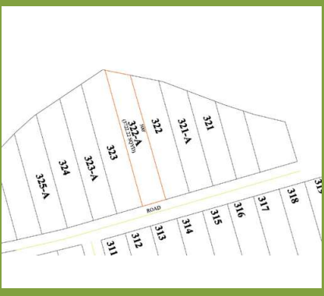

* **10% Rebate:** For those who pay the full amount within one month of the auction.
* **Additional 5% Rebate:** Available for payments made in US dollars through a banking transfer to the CDA account.

This auction presents a **golden investment opportunity** for those looking to expand their portfolio with premium commercial properties in Islamabad. Don’t miss your chance to invest in one of Pakistan’s most sought-after locations.

For further assistance and details, Ghandhara Estate is here to help you every step of the way.

<https://ghandharaestate.com/>

Ghandhara Estate

CDA Offers OPEN AUCTION OF COMMERCIAL PLOTS in Various Sectors of Islamabad. Auction will be held on1st October 2024 to 3rd October 2024 at Ghandhara Citizen Club, F-9 Park, Islamabad.

**PLOT NO. 322-A, INDUSTRIAL TRIANGLE KAHUTA**

|  |  |  |  |  |  |
| --- | --- | --- | --- | --- | --- |
| **Plot Location** | **Category** | **Plot Number** | **Size** | **FAR** | **Number of Stories Allowed** |
| INDUSTRIAL TRIANGLE KAHUTA | Industrial Plot | 277 | Irregular  4500.00 Sq.Yds | a) 1:1.2  b) 1:1.5  c) 1:1.6 |  |

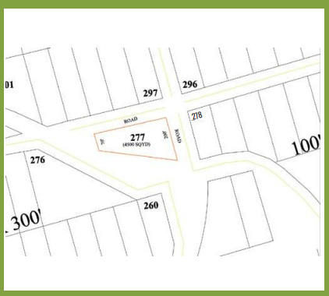

* **10% Rebate:** For those who pay the full amount within one month of the auction.
* **Additional 5% Rebate:** Available for payments made in US dollars through a banking transfer to the CDA account.

This auction presents a **golden investment opportunity** for those looking to expand their portfolio with premium commercial properties in Islamabad. Don’t miss your chance to invest in one of Pakistan’s most sought-after locations.

For further assistance and details, Ghandhara Estate is here to help you every step of the way.

<https://ghandharaestate.com/>

Ghandhara Estate

CDA Offers OPEN AUCTION OF COMMERCIAL PLOTS in Various Sectors of Islamabad. Auction will be held on1st October 2024 to 3rd October 2024 at Ghandhara Citizen Club, F-9 Park, Islamabad.

**PLOT NO. 271-A, INDUSTRIAL TRIANGLE KAHUTA**

|  |  |  |  |  |  |
| --- | --- | --- | --- | --- | --- |
| **Plot Location** | **Category** | **Plot Number** | **Size** | **FAR** | **Number of Stories Allowed** |
| INDUSTRIAL TRIANGLE KAHUTA | Industrial Plot | 271-A | Irregular  4886.66 Sq.Yds. | a) 1:1.2  b) 1:1.5  c) 1:1.6 |  |

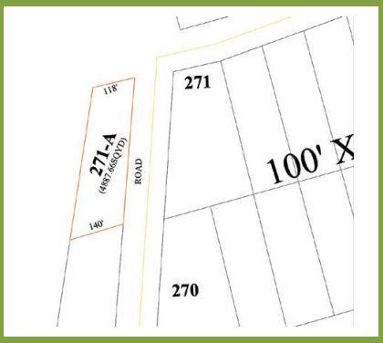

* **10% Rebate:** For those who pay the full amount within one month of the auction.
* **Additional 5% Rebate:** Available for payments made in US dollars through a banking transfer to the CDA account.

This auction presents a **golden investment opportunity** for those looking to expand their portfolio with premium commercial properties in Islamabad. Don’t miss your chance to invest in one of Pakistan’s most sought-after locations.

For further assistance and details, Ghandhara Estate is here to help you every step of the way.

<https://ghandharaestate.com/>

Ghandhara Estate

CDA Offers OPEN AUCTION OF COMMERCIAL PLOTS in Various Sectors of Islamabad. Auction will be held on1st October 2024 to 3rd October 2024 at Ghandhara Citizen Club, F-9 Park, Islamabad.

**PLOT NO.** **37-C, Orchard Scheme, Murree Road**

|  |  |  |  |  |  |
| --- | --- | --- | --- | --- | --- |
| **Plot Location** | **Category** | **Plot Number** | **Size** | **FAR** | **Number of Stories Allowed** |
| Orchard Scheme, Murree Road | Orchard | 37-C | 2.50 acres |  |  |

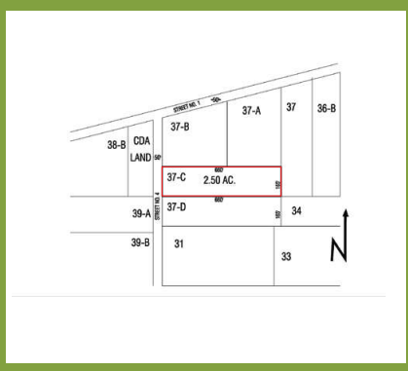

* **10% Rebate:** For those who pay the full amount within one month of the auction.
* **Additional 5% Rebate:** Available for payments made in US dollars through a banking transfer to the CDA account.

This auction presents a **golden investment opportunity** for those looking to expand their portfolio with premium commercial properties in Islamabad. Don’t miss your chance to invest in one of Pakistan’s most sought-after locations.

For further assistance and details, Ghandhara Estate is here to help you every step of the way.

<https://ghandharaestate.com/>

Ghandhara Estate

CDA Offers OPEN AUCTION OF COMMERCIAL PLOTS in Various Sectors of Islamabad. Auction will be held on1st October 2024 to 3rd October 2024 at Ghandhara Citizen Club, F-9 Park, Islamabad**. CLASS-III SHOPPING CENTRES**

**PLOT NO 2-D.** **, Bazar No. 1, G-9/1**

|  |  |  |  |  |  |
| --- | --- | --- | --- | --- | --- |
| **Plot Location** | **Category** | **Plot Number** | **Size** | **FAR** | **Number of Stories Allowed** |
| Bazar No. 1,  G-9/1 | CLASS-III SHOPPING CENTRE | 2-D | (30X40)  133.33 Sq.Yd | 1:3 | LG+G+01 |



* **10% Rebate:** For those who pay the full amount within one month of the auction.
* **Additional 5% Rebate:** Available for payments made in US dollars through a banking transfer to the CDA account.

This auction presents a **golden investment opportunity** for those looking to expand their portfolio with premium commercial properties in Islamabad. Don’t miss your chance to invest in one of Pakistan’s most sought-after locations.

For further assistance and details, Ghandhara Estate is here to help you every step of the way.

<https://ghandharaestate.com/>

Ghandhara Estate

CDA Offers OPEN AUCTION OF COMMERCIAL PLOTS in Various Sectors of Islamabad. Auction will be held on1st October 2024 to 3rd October 2024 at Ghandhara Citizen Club, F-9 Park, Islamabad**. CLASS-III SHOPPING CENTRES**

**PLOT NO 2-F.** **, Bazar No. 1, G-9/1**

|  |  |  |  |  |  |
| --- | --- | --- | --- | --- | --- |
| **Plot Location** | **Category** | **Plot Number** | **Size** | **FAR** | **Number of Stories Allowed** |
| Bazar No. 1,  G-9/1 | CLASS-III SHOPPING CENTRE | 2-F | (30X40)  133.33 Sq.Yd | 1:3 | LG+G+01 |



* **10% Rebate:** For those who pay the full amount within one month of the auction.
* **Additional 5% Rebate:** Available for payments made in US dollars through a banking transfer to the CDA account.

This auction presents a **golden investment opportunity** for those looking to expand their portfolio with premium commercial properties in Islamabad. Don’t miss your chance to invest in one of Pakistan’s most sought-after locations.

For further assistance and details, Ghandhara Estate is here to help you every step of the way.

<https://ghandharaestate.com/>

Ghandhara Estate

CDA Offers OPEN AUCTION OF COMMERCIAL PLOTS in Various Sectors of Islamabad. Auction will be held on1st October 2024 to 3rd October 2024 at Ghandhara Citizen Club, F-9 Park, Islamabad**. CLASS-III SHOPPING CENTRES**

**PLOT NO 2-G.** **, Bazar No. 1, G-9/1**

|  |  |  |  |  |  |
| --- | --- | --- | --- | --- | --- |
| **Plot Location** | **Category** | **Plot Number** | **Size** | **FAR** | **Number of Stories Allowed** |
| Bazar No. 1,  G-9/1 | CLASS-III SHOPPING CENTRE | 2-G | (30X40)  133.33 Sq.Yd | 1:3 | LG+G+01 |

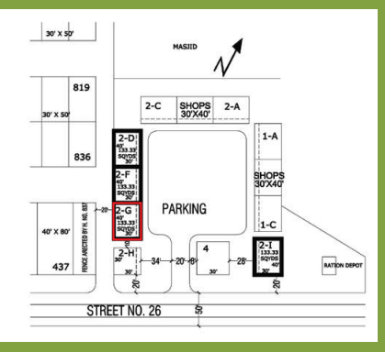

* **10% Rebate:** For those who pay the full amount within one month of the auction.
* **Additional 5% Rebate:** Available for payments made in US dollars through a banking transfer to the CDA account.

This auction presents a **golden investment opportunity** for those looking to expand their portfolio with premium commercial properties in Islamabad. Don’t miss your chance to invest in one of Pakistan’s most sought-after locations.

For further assistance and details, Ghandhara Estate is here to help you every step of the way.

<https://ghandharaestate.com/>

Ghandhara Estate

CDA Offers OPEN AUCTION OF COMMERCIAL PLOTS in Various Sectors of Islamabad. Auction will be held on1st October 2024 to 3rd October 2024 at Ghandhara Citizen Club, F-9 Park, Islamabad**. CLASS-III SHOPPING CENTRES**

**PLOT NO 2-I.** **, Bazar No. 1, G-9/1**

|  |  |  |  |  |  |
| --- | --- | --- | --- | --- | --- |
| **Plot Location** | **Category** | **Plot Number** | **Size** | **FAR** | **Number of Stories Allowed** |
| Bazar No. 1,  G-9/1 | CLASS-III SHOPPING CENTRE | 2-I | (30X40)  133.33 Sq.Yd | 1:3 | LG+G+01 |

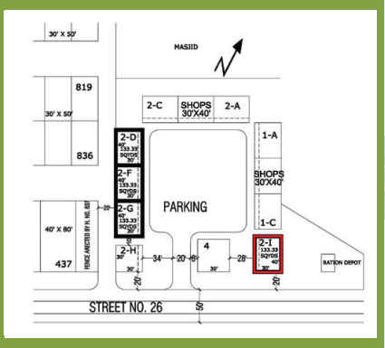

* **10% Rebate:** For those who pay the full amount within one month of the auction.
* **Additional 5% Rebate:** Available for payments made in US dollars through a banking transfer to the CDA account.

This auction presents a **golden investment opportunity** for those looking to expand their portfolio with premium commercial properties in Islamabad. Don’t miss your chance to invest in one of Pakistan’s most sought-after locations.

For further assistance and details, Ghandhara Estate is here to help you every step of the way.

<https://ghandharaestate.com/>

Ghandhara Estate

CDA Offers OPEN AUCTION OF COMMERCIAL PLOTS in Various Sectors of Islamabad. Auction will be held on1st October 2024 to 3rd October 2024 at Ghandhara Citizen Club, F-9 Park, Islamabad**. CLASS-III SHOPPING CENTRES**

**PLOT NO 1.** **, Bazar No. 6, G-9/2**

|  |  |  |  |  |  |
| --- | --- | --- | --- | --- | --- |
| **Plot Location** | **Category** | **Plot Number** | **Size** | **FAR** | **Number of Stories Allowed** |
| Bazar No. 6,  G-9/2 | CLASS-III SHOPPING CENTRE | 1 | (30X40)  133.33 Sq.Yd | 1:3 | LG+G+01 |

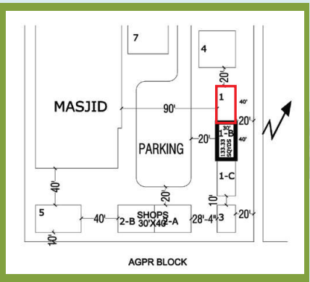

* **10% Rebate:** For those who pay the full amount within one month of the auction.
* **Additional 5% Rebate:** Available for payments made in US dollars through a banking transfer to the CDA account.

This auction presents a **golden investment opportunity** for those looking to expand their portfolio with premium commercial properties in Islamabad. Don’t miss your chance to invest in one of Pakistan’s most sought-after locations.

For further assistance and details, Ghandhara Estate is here to help you every step of the way.

<https://ghandharaestate.com/>

Ghandhara Estate

CDA Offers OPEN AUCTION OF COMMERCIAL PLOTS in Various Sectors of Islamabad. Auction will be held on1st October 2024 to 3rd October 2024 at Ghandhara Citizen Club, F-9 Park, Islamabad**. CLASS-III SHOPPING CENTRES**

**PLOT NO 1-B.** **, Bazar No. 6, G-9/2**

|  |  |  |  |  |  |
| --- | --- | --- | --- | --- | --- |
| **Plot Location** | **Category** | **Plot Number** | **Size** | **FAR** | **Number of Stories Allowed** |
| Bazar No. 6,  G-9/2 | CLASS-III SHOPPING CENTRE | 1-B | (30X40)  133.33 Sq.Yd | 1:3 | LG+G+01 |

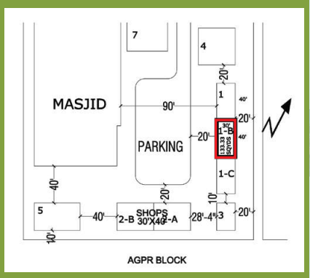

* **10% Rebate:** For those who pay the full amount within one month of the auction.
* **Additional 5% Rebate:** Available for payments made in US dollars through a banking transfer to the CDA account.

This auction presents a **golden investment opportunity** for those looking to expand their portfolio with premium commercial properties in Islamabad. Don’t miss your chance to invest in one of Pakistan’s most sought-after locations.

For further assistance and details, Ghandhara Estate is here to help you every step of the way.

<https://ghandharaestate.com/>

Ghandhara Estate

CDA Offers OPEN AUCTION OF COMMERCIAL PLOTS in Various Sectors of Islamabad. Auction will be held on1st October 2024 to 3rd October 2024 at Ghandhara Citizen Club, F-9 Park, Islamabad**. CLASS-III SHOPPING CENTRES**

**PLOT NO 1-B.** **, Bazar No. 9, G-9/3**

|  |  |  |  |  |  |
| --- | --- | --- | --- | --- | --- |
| **Plot Location** | **Category** | **Plot Number** | **Size** | **FAR** | **Number of Stories Allowed** |
| Bazar No. 9,  G-9/3 | CLASS-III SHOPPING CENTRE | 1-B | (30X40)  133.33 Sq.Yd | 1:3 | LG+G+01 |

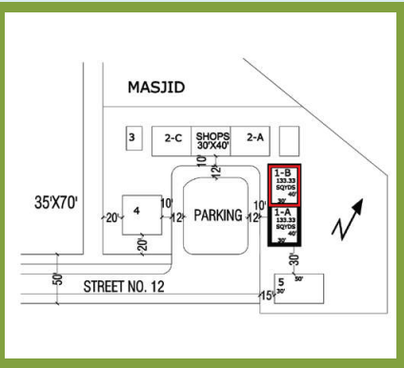

* **10% Rebate:** For those who pay the full amount within one month of the auction.
* **Additional 5% Rebate:** Available for payments made in US dollars through a banking transfer to the CDA account.

This auction presents a **golden investment opportunity** for those looking to expand their portfolio with premium commercial properties in Islamabad. Don’t miss your chance to invest in one of Pakistan’s most sought-after locations.

For further assistance and details, Ghandhara Estate is here to help you every step of the way.

<https://ghandharaestate.com/>

Ghandhara Estate

CDA Offers OPEN AUCTION OF COMMERCIAL PLOTS in Various Sectors of Islamabad. Auction will be held on1st October 2024 to 3rd October 2024 at Ghandhara Citizen Club, F-9 Park, Islamabad**. CLASS-III SHOPPING CENTRES**

**PLOT NO 7-A** **, Bazar No. 13,G-11/4**

|  |  |  |  |  |  |
| --- | --- | --- | --- | --- | --- |
| **Plot Location** | **Category** | **Plot Number** | **Size** | **FAR** | **Number of Stories Allowed** |
| Bazar No. 13,  G-11/4 | CLASS-III SHOPPING CENTRE | 7-A | (30X40)  133.33 Sq.Yd | 1:3 | LG+G+01 |

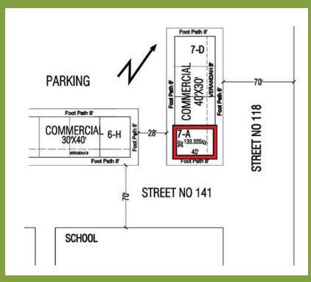

* **10% Rebate:** For those who pay the full amount within one month of the auction.
* **Additional 5% Rebate:** Available for payments made in US dollars through a banking transfer to the CDA account.

This auction presents a **golden investment opportunity** for those looking to expand their portfolio with premium commercial properties in Islamabad. Don’t miss your chance to invest in one of Pakistan’s most sought-after locations.

For further assistance and details, Ghandhara Estate is here to help you every step of the way.

<https://ghandharaestate.com/>

Ghandhara Estate

CDA Offers OPEN AUCTION OF COMMERCIAL PLOTS in Various Sectors of Islamabad. Auction will be held on1st October 2024 to 3rd October 2024 at Ghandhara Citizen Club, F-9 Park, Islamabad**. CLASS-III SHOPPING CENTRES**

**PLOT NO 4, Bazar No. 2, G-10/2**

|  |  |  |  |  |  |
| --- | --- | --- | --- | --- | --- |
| **Plot Location** | **Category** | **Plot Number** | **Size** | **FAR** | **Number of Stories Allowed** |
| Bazar No. 2,  G-10/2 | CLASS-III SHOPPING CENTRE | 4 | (30X40)  133.33 Sq.Yd | 1:3 | LG+G+01 |

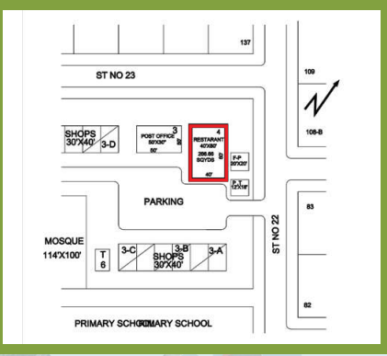

* **10% Rebate:** For those who pay the full amount within one month of the auction.
* **Additional 5% Rebate:** Available for payments made in US dollars through a banking transfer to the CDA account.

This auction presents a **golden investment opportunity** for those looking to expand their portfolio with premium commercial properties in Islamabad. Don’t miss your chance to invest in one of Pakistan’s most sought-after locations.

For further assistance and details, Ghandhara Estate is here to help you every step of the way.

<https://ghandharaestate.com/>